MACHINE LEARNING ASSIGNMENT-2

Video link-

<https://drive.google.com/file/d/1D_sC2dF_X_Fjg4764Vhm9wD8sxhme2Rf/view?usp=sharing>

1. Read the provided CSV file ‘data.csv’

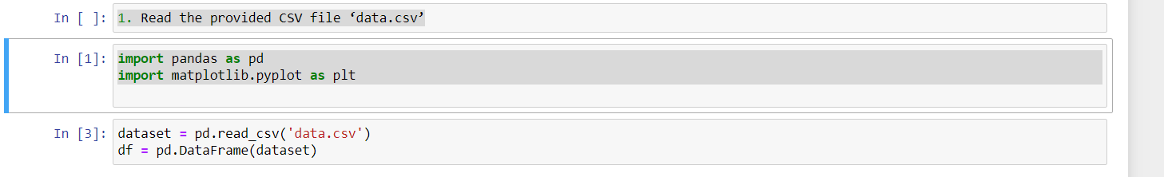

1. Show the basic statistical description about the data.

df.describe()

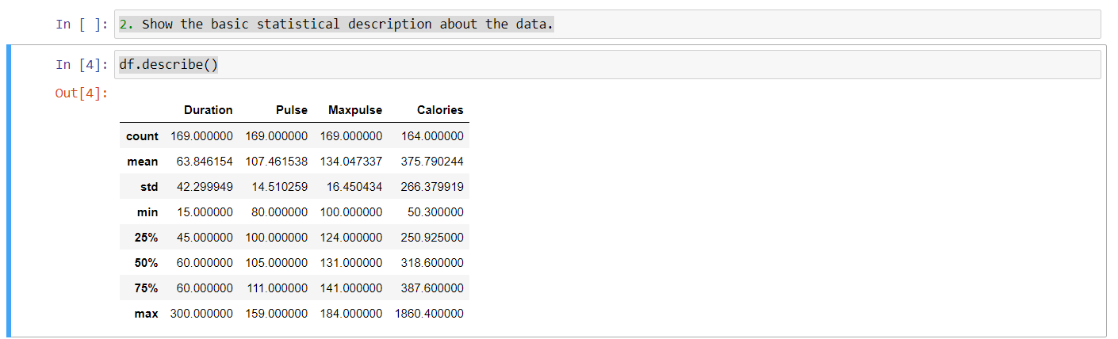

3.Check if the data has null values.

- a. Replace the null values with the mean

nullVal = pd.DataFrame(df[df.isna().any(axis=1)])

print("Rows that has null values:")

print(nullVal)

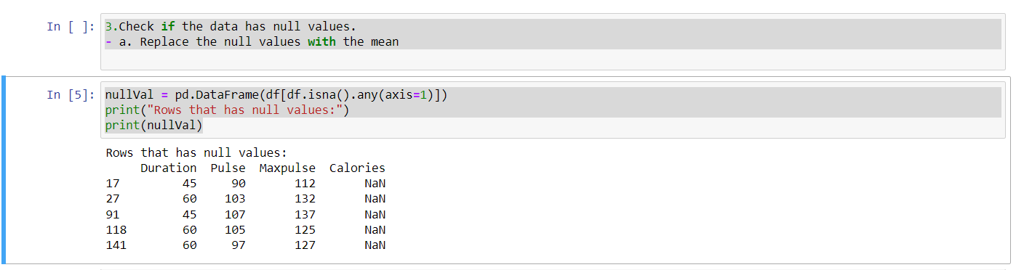

nullValInx = list(nullVal.index.values)

df = df.fillna(round(df.mean(),1)) #replace the null values with the respective mean value of the column

updated_val = pd.DataFrame(df,index=nullValInx)

print("After Update:")

updated_val

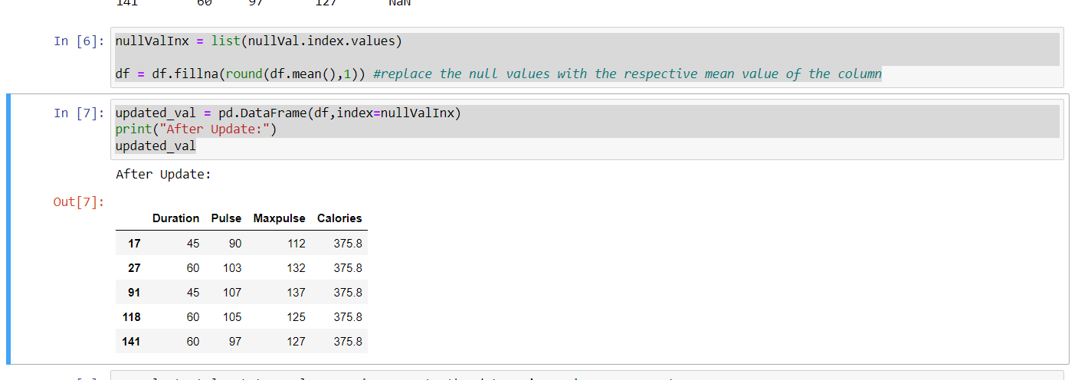

4.Select at least two columns and aggregate the data using: min, max, count, mean.

df.agg({'Pulse' : ['max', 'min', 'count', 'mean'], 'Calories' : ['max', 'min', 'count', 'mean']})

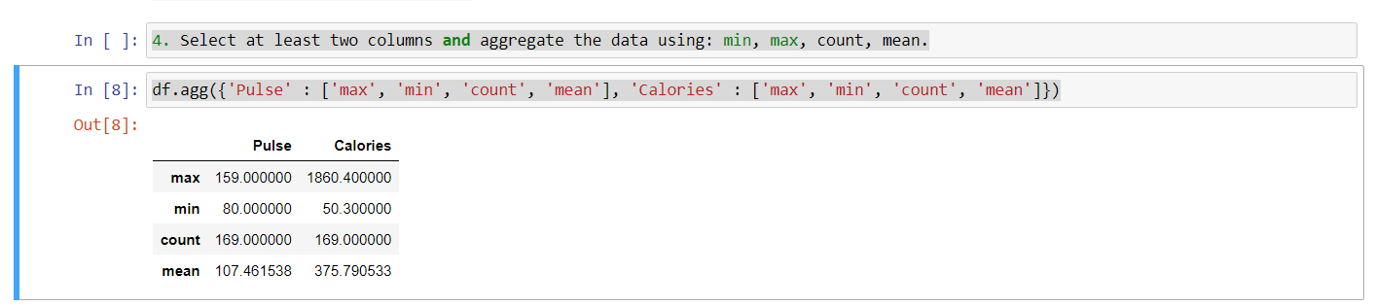

5. Filter the dataframe to select the rows with calories values between 500 and 1000

df_greater_500 = df[df['Calories']>=500] #filter rows with calories above 500

df_filter = df_greater_500[df_greater_500["Calories"]<=1000] #from the above result, filter the rows with calories below 1000

df_filter

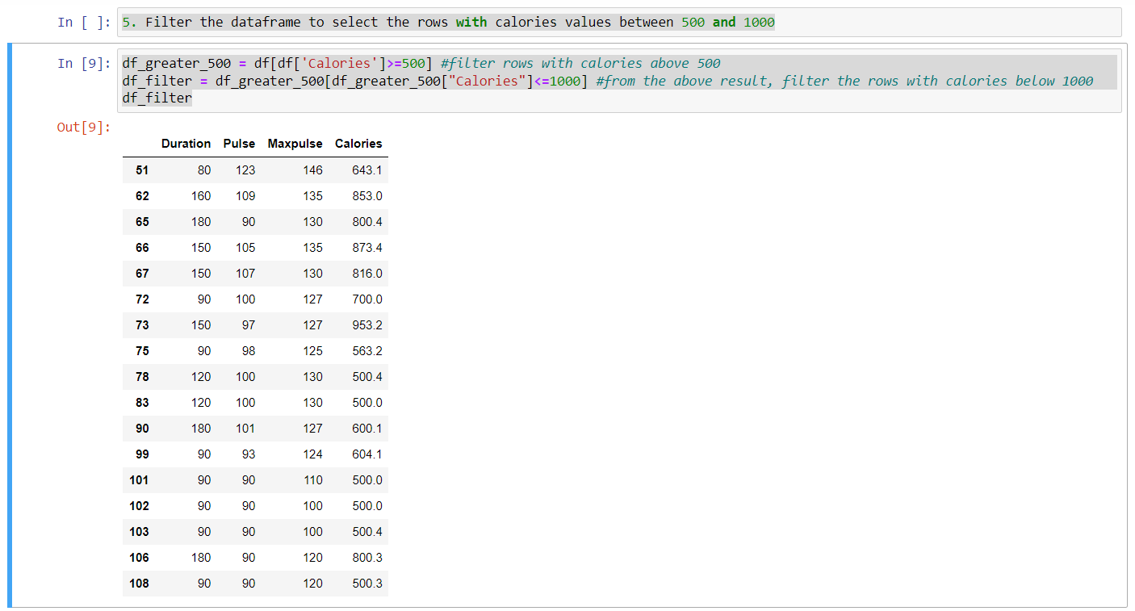

6. Filter the dataframe to select the rows with calories values > 500 and pulse <100.

df_great_500 = df[df['Calories']>500]

df_filter = df_great_500[df_great_500["Pulse"]<100]

df_filter

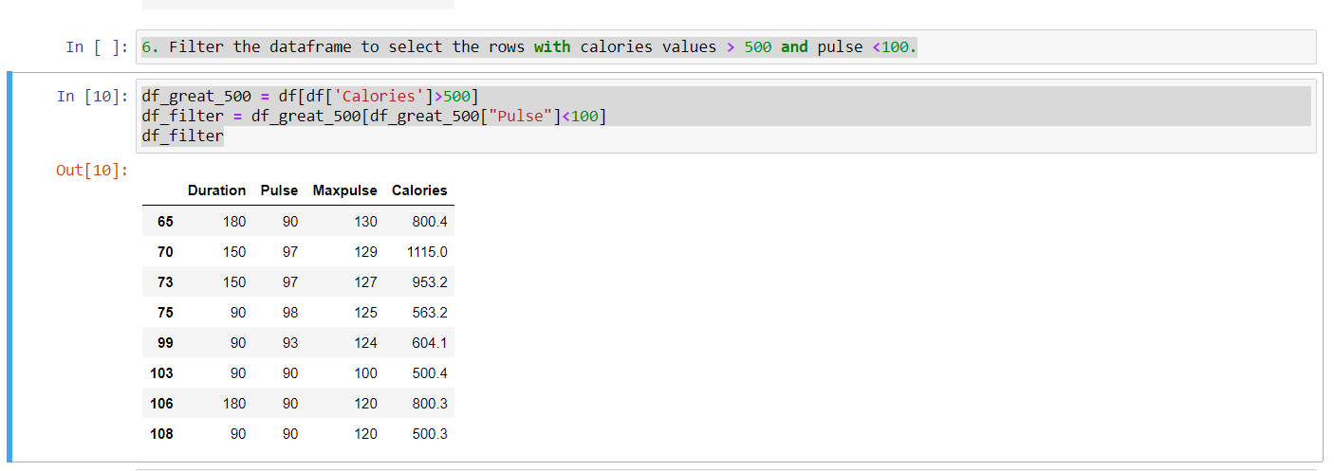

7. Create a new “df_modified” dataframe that contains all the columns from df except for “Maxpulse”

df_modified = df[["Duration","Pulse","Calories"]]

df_modified

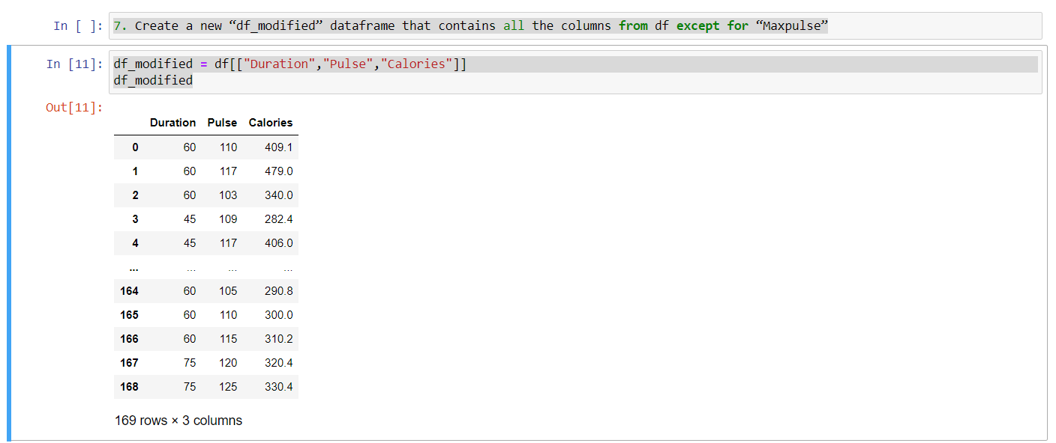

8. Delete the “Maxpulse” column from the main df dataframe

del df["Maxpulse"]

df

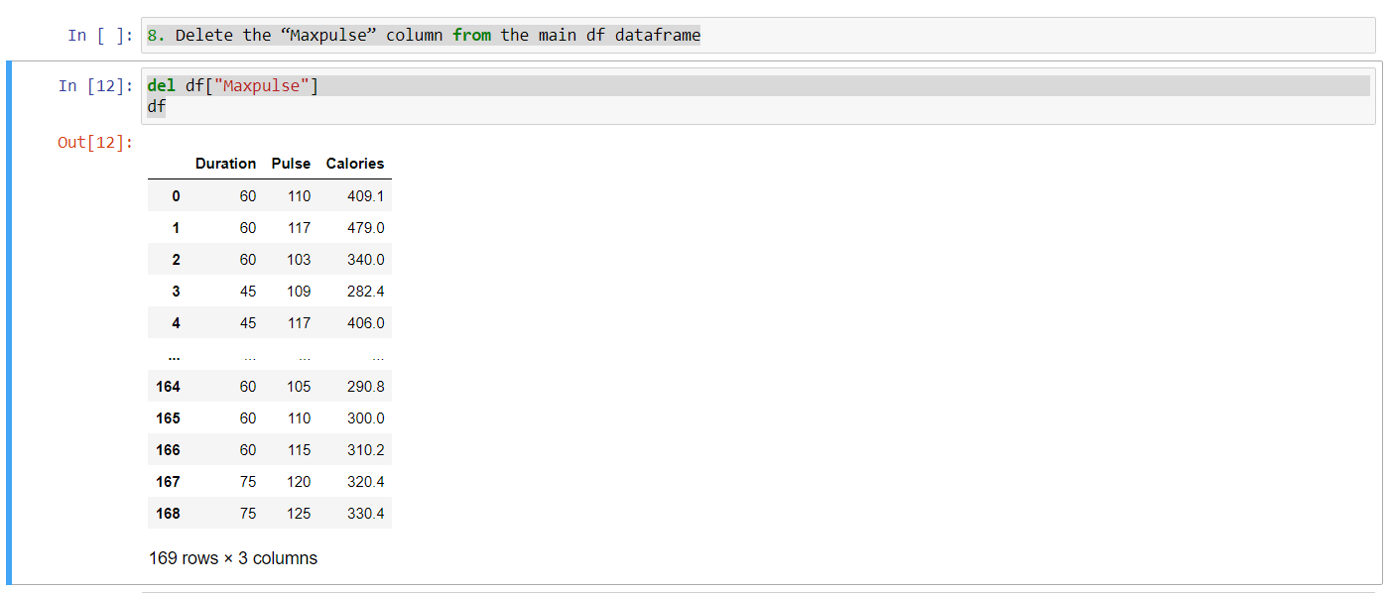

9. Convert the datatype of Calories column to int datatype.

df["Calories"] = df["Calories"].astype(int)

df

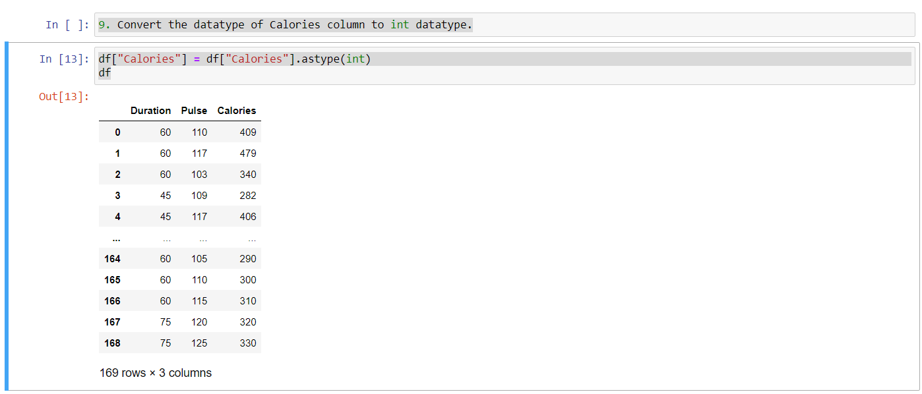

10. Using pandas create a scatter plot for the two columns (Duration and Calories)

df.plot.scatter(x='Duration', y='Calories', c='DarkBlue')

plt.show()

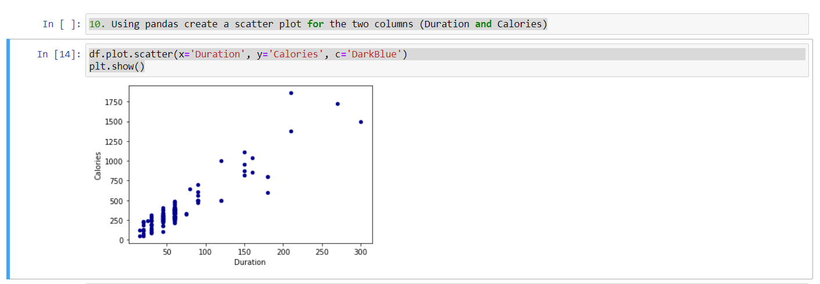

### 2. Scikit-learn

1. Implement Naïve Bayes method using scikit-learnlibrary.

- a. Use the glass dataset available in Link also provided in your assignment.

import numpy as np

import random as rnd

from sklearn.naive_bayes import GaussianNB

from sklearn.model_selection import train_test_split

from sklearn.metrics import accuracy_score

from sklearn import metrics

from sklearn.svm import SVC, LinearSVC

from sklearn.neighbors import KNeighborsClassifier

# reading the dataset file

df = pd.read_csv('glass.csv')

X = df.drop(['Type'], axis=1)

Y = df["Type"]

#splitting the dataset into training set and testing set

X_Train, X_Test, Y_Train, Y_Test = train_test_split(X, Y, test_size=0.25,random_state = 0)

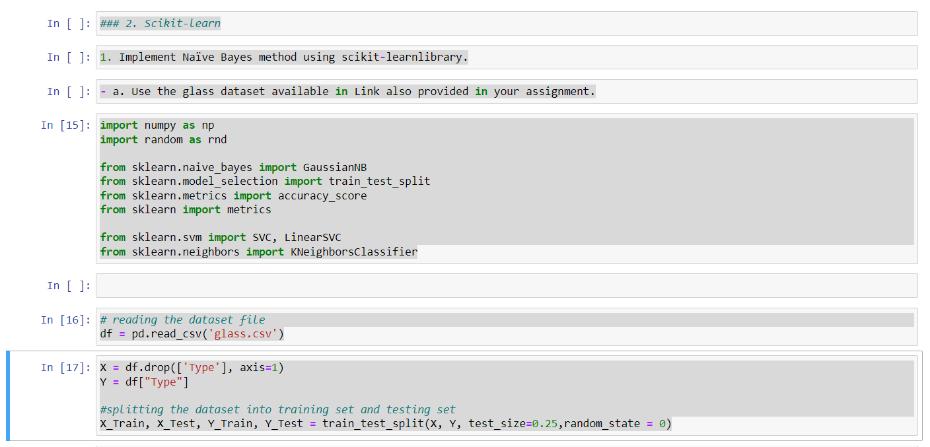

1. Evaluate the model on testing part using score and classification_report(y_true, y_pred)

# Naive Bayes

gnb = GaussianNB()

gnb.fit(X_Train,Y_Train)

# Predicting the Test set result

Y_Pred = gnb.predict(X_Test)

# evaluating the model

print("Gaussian Naive Bayers Accuracy is:",round(accuracy_score(Y_Test,Y_Pred) * 100,2))

print("\nClassification Report:\n\n",metrics.classification_report(Y_Test,Y_Pred,zero_division=0))

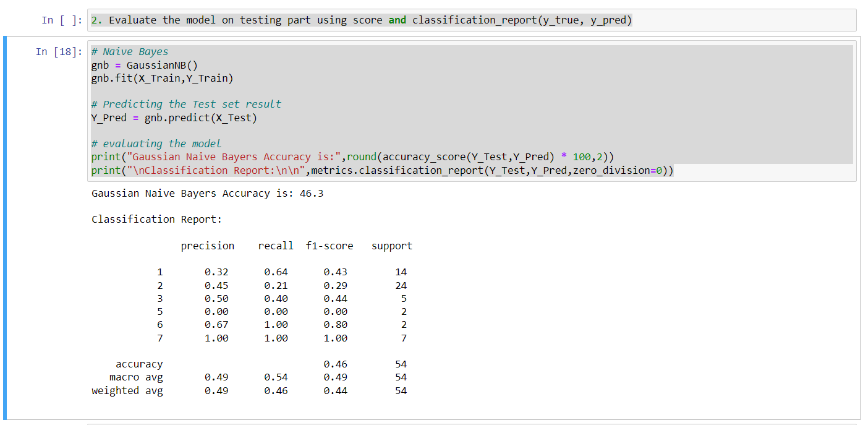

1. Implement linear SVM method using scikit library

- a. Use the glass dataset available in Link also provided in your assignment.

- b. Use train_test_split to create training and testing part.

2. Evaluate the model on testing part using score and classification_report(y_true, y_pred)

# SVM model

svc = SVC(kernel='linear')

svc.fit(X_Train, Y_Train)

# Predicting the Test set result

Y_pred = svc.predict(X_Test)

# evaluating the model

print("SVM accuracy is:", round(accuracy_score(Y_Test,Y_pred) * 100, 2))

print("\nClassification Report:\n\n",metrics.classification_report(Y_Test,Y_pred,zero_division=0))

